 | SUMMER INTERNSHIP REPORT | 
On

"Embedded Systems”
at
Wings Automobile Products Pvt. Limited
Faridabad, Haryana
Duration
15th May 2026 – 12th July 2026
Team:
Harshit Sharma, Roll No: 2311401107
Ramnarayan Balai, Roll No: 2311401230
Anuj Gopal Namdeo, Roll No: 2311401118
Department of Electronics and Communication Engineering, MANIT Bhopal

Preface
The project presents the design and development of an Automatic High Beam Control System (AHBCS) for Automotives aimed at enhancing the automotive’s safety, Following Traffic Rules and spreading driving comfort to all the vehicles passing through. The system intelligently controls the High / Low beam Head Lights as well as issuing Dipper to passing Vehicles, based on ambient light and opposing vehicle conditions, thereby reducing glare and improving visibility for both the driver and oncoming vehicles.
The Internship training includes following
- The Concept & Hardware design
- Preparation of Schematics & PCB Art Work
- PCB Fabrication process at Prototype levels
- PCB Stuffing as per BOM
- Testing of Basic Hardware without loading the software
- Software Architecture Planning & Embedded Code Execution
The embedded software for this project was developed on the Keil µVision IDE, tailored for the MM32F0010 microcontroller. The development process included requirement analysis, software flowchart creation, device driver integration, code implementation, and microcontroller programming. Extensive testing and debugging ensured that the control logic responds accurately to environmental changes and beam switching conditions.
The scope of the project was focused to provide In-depth practical exposure to the domains of Embedded systems, Circuit design, Software Integration, Real Time In Circuit Emulation Using Dedicated Emulation Tool and Real-time testing.

Acknowledgement

We sincerely convey our Regards to Dr. R.K. Baghel Sir, Maulana Azad National Institute of Technology, Bhopal for providing the opportunity in communication with M/s Wings Automobile Product Pvt. Ltd. for taking up our Internship schedule.

We also like to express our sincere gratitude to Wings Automobile Products Pvt. Ltd. for offering us the opportunity to undertake our internship and gain valuable practical experience. We extend our Regards to the Director (Technical) - Mr. Sanjai Vishwakarma Sir, Mr. Bhujvir Singh (Head of Q.C.), Mr. Devendra kumar (Senior R&D design engineer), Mr. Pitamber Tiwari Sir (Senior Testing Engineer) Mr. Krishna Vishwakarma Sir (Sr. Supervisor) for their guidance for entire Project execution.

Table of Contants

1. Internship Objectives 6
2. Team Members' Profile 7
3. Problem Statement and Need Analysis 8
3.1 Caused by High-Beam Glare: 8
3.2 Data and Reports: 9
3.3 Form an Automated Solution: 9
4.1 Overview: 11
4.2 Detailed Description of Tasks: 11
4.2.1 Testing of E-Winker Circuit: 11
4.2.2 Defining Project: 12
Project Aim: “Design a circuit that automatically control the Head Light of Automobiles based on the conditions given: 12
5. Project Design 13
5.1 Hardware Design 13
5.1.1 Schematic Designing: 13
5.1.2 Hardware Description:…………………………………………………………………………………………………….13
5.1.3 Footprint selection: 18
5.1.4 PCB Designing: 18
5.1.5 PCB Fabrication Process: 21
5.1.6 Soldering of PCB Components: 23
5.1.7 Continuity Testing and Debugging: 24
5.1.8 Generation of Bill of Materials (BOM): 24
5.2 Software Design 25
5.2.1 Software Listing of Requirements: 25
5.2.2 Software Flow Chart: 27
5.2.3 Description of Device Drivers 28
5.2.4 Embedded Software Development on Keil 28
6. Code Testing and Debugging: 28
7. Code Uploading and Microcontroller Programming: 28
8. Challenges Faced and Solutions 29
9. Outcome and Results 31
AHBCS prototype successfully met its core objectives: 31
Performance: 31
10. Learnings and Skills Acquired 31
10.1 Technical Skills: 31
10.2 Soft Skills: 32
11. Conclusion 32
12. Annexure 33

1. Internship Objectives
- To gain hands-on experience in embedded systems and circuit design.
- To understand and solve real-world problems related to challenging practical implementation of the Real World Electronic Projects.
- To work within a team and gain technical knowledge of project designing & implementation.
- To develop 3-numbers of prototypes of Automatic High Beam Control System (AHBCS).

2. Team Members' Profile

- Mr. Harshit Sharma:
3rd Year student,
Scholar No.-2311401107,
MANIT Bhopal.
- Mr. Anuj Gopal Namdeo:
3rd Year student,
Scholar No.-2311401118,
MANIT Bhopal.
- Mr. Ramnarayan Balai:
3rd Year student,
Scholar No.-2311401230,
MANIT Bhopal.

3. Problem Statement and Need Analysis
Uncontrolled use of high-beam headlights during night driving presents a significant and often underestimated safety hazard, both on Single as well as multilane highways and undivided roads. When oncoming vehicles use high beams, they emit intense light directly into the eyes of the approaching driver, causing temporary blindness or glare—a condition known as disability glare. This drastically reduces visibility and reaction time, increasing the risk of head-on collisions, pedestrian accidents, and run-off-road crashes.

3.1 Caused by High-Beam Glare:
- Driver Blindness and Reduced Reaction Time:
High-beam glare can reduce a driver’s visual acuity by up to 90%, even after the source of light is no longer in view. It takes the human eye 3–5 seconds to recover from glare. At a speed of 80 km/h, this translates to a blind travel distance of 67–111 meters, during which a vehicle is effectively out of control.
- Pedestrian and Cyclist Danger:
High beams make it difficult to notice pedestrians or cyclists on the roadside. This is especially hazardous in rural or semi-urban areas with poor street lighting.
- Fatigue and Aggressive Driving:
Prolonged exposure to high-beam glare contributes to driver fatigue, irritation, and even road rage, as drivers feel disrespected or threatened by inappropriate beam usage.

- Increased Risk for Elderly Drivers:
According to ophthalmology studies, older drivers take longer to recover from glare and are more vulnerable to high-beam effects, further increasing the risk for this demographic.

3.2 Data and Reports:
- According to a report by the Ministry of Road Transport and Highways (MoRTH), Government of India (2022), around 20% of fatal night-time accidents on national highways are attributed to poor visibility and glare from oncoming traffic.
- A study conducted by the Central Road Research Institute (CRRI) revealed that more than 70% of drivers use high-beam headlights inappropriately, especially in rural and semi-urban areas, where street lighting is sparse or absent.
- In a 2019 survey by Save LIFE Foundation, over 65% of drivers reported difficulty driving at night due to glare from oncoming headlights.

3.3 Form an Automated Solution:
Despite regulations prohibiting high beam use in certain conditions (e.g., within city limits, when following or meeting another vehicle), enforcement is weak, and compliance is low. Most existing vehicles lack automatic high-beam control systems, especially in budget or two-wheeler segments predominant in India.

This calls a definite need for an intelligent, affordable, and scalable solution—such as the Automatic High Beam Control System (AHBCS)—to detect oncoming traffic and ambient conditions and automatically switch between high and low beams. Such a system not only ensures road safety but also promotes driver comfort, courtesy, and compliance without relying on manual intervention.

- Project Title:
Automatic High Beam Control System (AHBCS)

4.1 Overview:
The tasks included research, circuit testing, schematic and PCB design, embedded code development, mechanical integration, and final testing

4.2 Detailed Description of Tasks:
4.2.1 Testing of E-Winker Circuit: As a preface before going for bigger project straight a way we were given a task of understanding & testing the E-Winker module to understand its operation and get familiar with the Electronic Circuits and Testing Equipments.
- E-Winker circuit is used for controlling the indicator lights of automobiles.
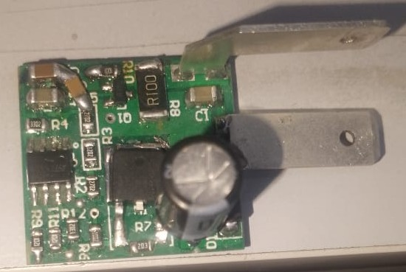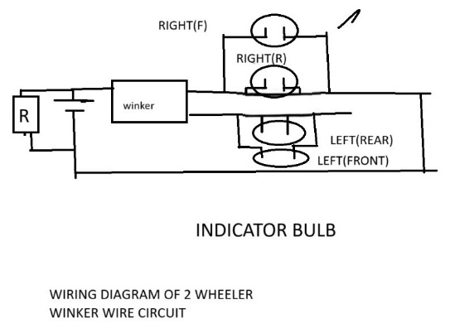
- This circuit is designed in such a way that the frequency of the blinking is doubled when one of the lights (left/right) is broken or damaged i.e. under half load condition.
- We Measured ON Time, OFF Time, and calculated duty cycle, frequency and flash rate using Oscilloscope at different operating voltages in the range of 11V to 16V.
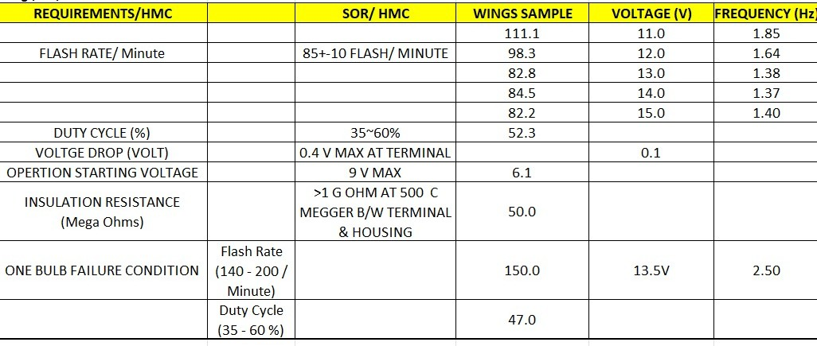

4.2.2 Defining The Project ‘AHBCS’:

Problem statement of our project: “Design a circuit that automatically control the Head Light of Automobiles based on the conditions given:

Master Vehicle | Slave Vehicle | Action
High Beam | High Beam | Give Deeper and Low Beam
High Beam | Low Beam | Low Beams
Low Beam | High Beam | Give Deeper and Low Beam
Low Beam | Low Beam | Remain same

4.2.3 Components Requirement Analysis for AHBCS:
Identified microcontroller MM32F0010, Sensors - LDR, Relay Modules, 5V Regulator and other associate Components like capacitors, resistors, Diodes, Zeners, Transistors, Darlington Pair Modules) for power supply, and Transistor, Resister and Diode for driver circuits needed for AHBCS, LED for Health Monitoring of system.

5. Project Design

5.1 Hardware Design

5.1.1 Schematic Designing:
Designed complete circuit schematic in Altium Designer.
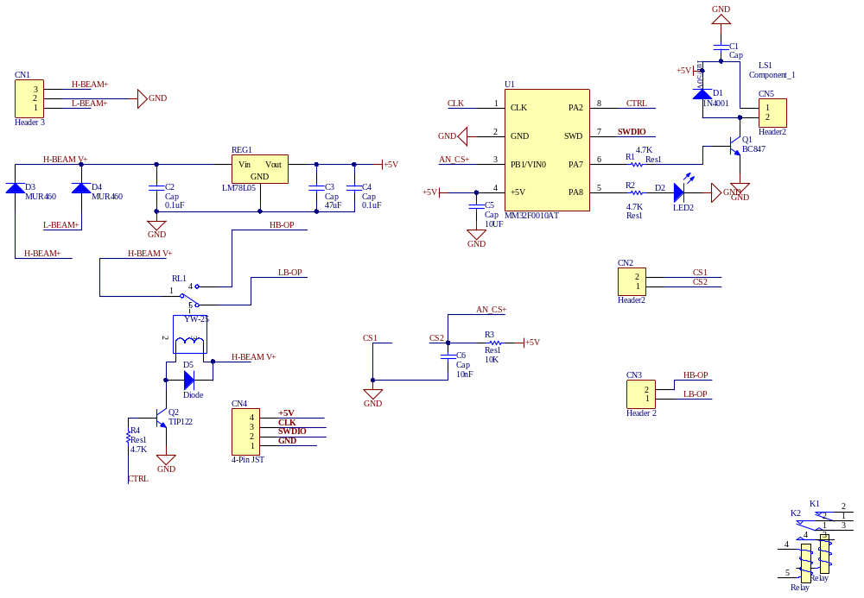
Schematic Design for AHBCS Circuit.
5.1.2 HARDWARE DESCRIPTION
CN1 : Connector for DC power supply up to 12V. It has one two inputs for high beam and low beam and one ground terminal.
D3 : MUR460 diode for performing OR operation on the two supplies for high beam and low beam. D3 is for High beam supply. It has its input from the high beam supply and output at the H-BEAM V+ node.
D4 : MUR460 diode for performing OR operation on the two supplies for high beam and low beam. D4 is for low beam supply. It has its input from the low beam supply and output at the H-BEAM V+ node.
C2 : Capacitor with value 0.1uF. It is lowers the sudden changes in the supply. One of its terminals is grounded and the other to the H-BEAM V+ node.
REG1 : Voltage regulator LM78L05 for regulating the 12V input DC supply to 5V regulated DC supply. It has three terminals, - Vin for common ground, Vout for output of 5V regulated DC supply, and one ground terminal.
C3 : Capacitor with value 47uF. It is lowers the ripples from the output of REG1. One of its terminals is grounded and the other is connected to the output pin of REG1.
C4 : Capacitor with value 0.1uF. It is lowers the ripples from the output of REG1. One of its terminals is grounded and the other is connected to the output pin of REG1 in parallel with C3.
RL1 : Relay SC15-S-DC12V. It has 5 pins – Two pins( 2 and 3) for the coil of relay, pin 1 for power supply from H-BEAM V+, pin 4 for the High Beam output and pin 5(Normally Closed) for the low Beam Output.
D5 : Diode IN4001 for preventing the reverse current flow from the power supply(H-BEAM V+) to the transistor Q2 in order to prevent the excess heating of the transistor. Its P terminal is connected to the Collector of the transistor and the N Terminal to the H-BEAM V+ supply.
Q2 : Transistor TIP122. It is a Darlington paired NPN transistor with high gain & high Collector current transistor used for driving the relay coil in saturation mode by taking the control signal from the microcontroller and acting as a switch for the current flow from the supply of the relay to its ground. The Base is connected to the Control Signal(CTRL) from Pin 8 of the uC IC, Collector is connected to pin 2 of the relay and the emitter terminal is connected to the ground.
CN4 : Connector for the programming of Microcontroller. It has 4 pins – Clock, +5V regulated DC supply, SWDIO( data input- output), Ground.
C6 : Capacitor with value 10nF. It prevents sudden spikes from the +5V regulated DC supply. One of its terminals is connected to the connector pin CS2 for LDR sensor and other to the ground.
R3 : Resistor with value 10K. It acts as a voltage divider for the LDR sensor to prevent excess power loss due to high voltage. One terminal connected to the 5V supply and other to the LDR connector pin CS2.
CN3 : Connector for the High Beam and low Beam Output. Two terminals – One for High beam output and other for Low beam output.
CN2 : Connector for the LDR sensor. Two pins – CS1 and CS2 Connector to the sensor.
U1 : Microcontroller IC MM32F0010. Microcontroller IC for controlling the High Beam and Low beam outputs by taking inputs from the sensor. It is an 8 pin uC:
Pin 1: Pin for Clock input.
Pin 2: Ground pin.
Pin 3: Takes input from the LDR sensor. Connected to the AN-CS+ net which takes voltage input from the CS2 terminal of the LDR.
Pin 4: +5V DC regulated supply pin.
Pin 5: PA8 Pin of the uC connected to the LED2 via a resistor.
Pin 6: PA7 pin of the uC for driving the buzzer circuit. Connected to the base of the transistor Q1.
Pin 7: SWDIO pin for data transfer.
Pin 8: PA2 pin of uC for giving the control signal to the transistor Q2 for driving the relay circuit.
R2: Resistor of value 4.7K.One terminal connected to the pin 5 of uC and other to the P terminal of LED2.
LED2: LED for displaying the health of the system.
R1: Resistor of value 4.7K connected to pin 6 of uC and base of transistor Q1.
Q1: Transistor BC847. It drives the buzzer by taking input form pin 6 to its base. Its emitter terminal is grounded and collector terminal to the buzzer terminal 2.
CN5: Buzzer with 2 terminals. One terminal connected to the collector of Q1 transistor and other terminal to the +5V regulated DC supply.
D1: Diode IN4001. It prevents the reverse current flow from the supply into the transistor Q1 in order to prevent reverse polarity connection at the input side. Its P terminal is connected to the collector of transistor Q1 and N terminal to the +5V regulated DC supply.
C1: Capacitor with value 1uF. It lowers the surges & spikes associated with the input supply in the +5V regulated DC output. One terminal connected to the ground and other to the buzzer terminal 1.
R4: Resistor of value 4.7K. One terminal connected to the Pin 8 of the uC sends the Control signal to the base of transistor Q2.

5.1.3 Footprint selection:
Selected the footprints for PCB Components, some from default library and other from self-made library.
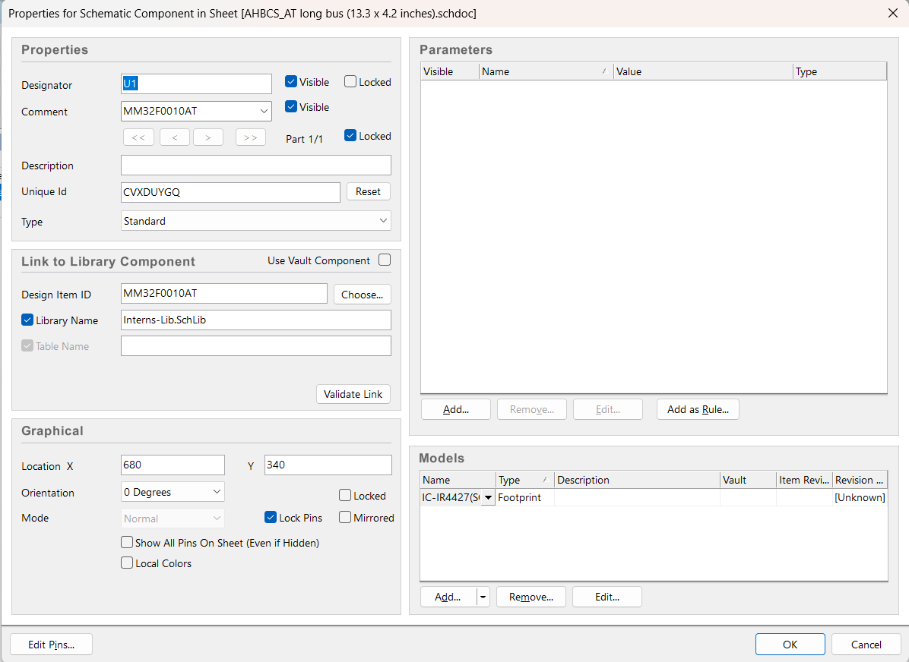
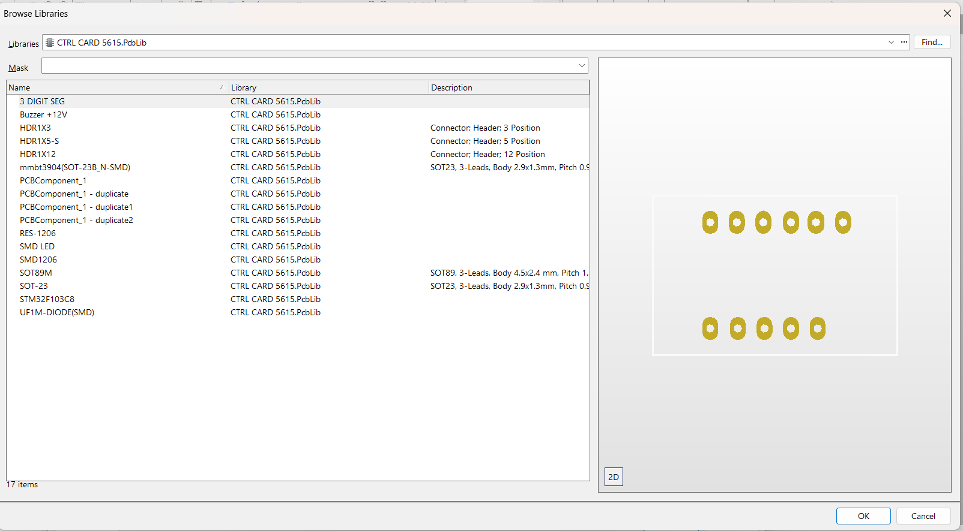

5.1.4 PCB Designing:
- Send all the components from schematic to PCB file
- Placing: Place them according to design rules like Power track components together and signal track components together.
- Input components on left side and output components on right side.
- Routing: draw tracks and set wire width accordingly.
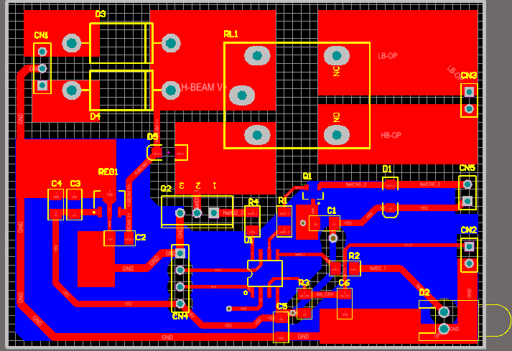
Top Layer
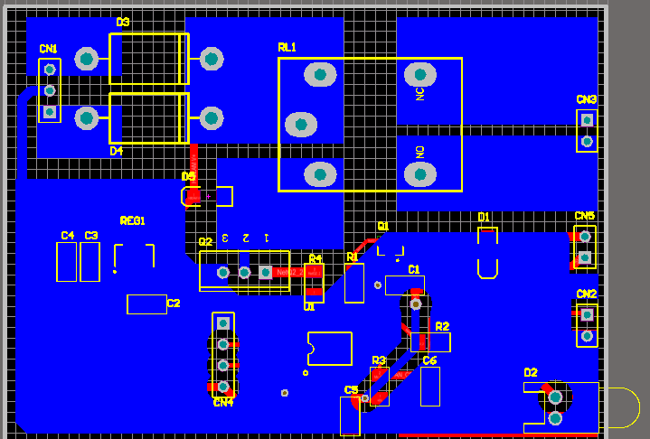
Bottom layer.

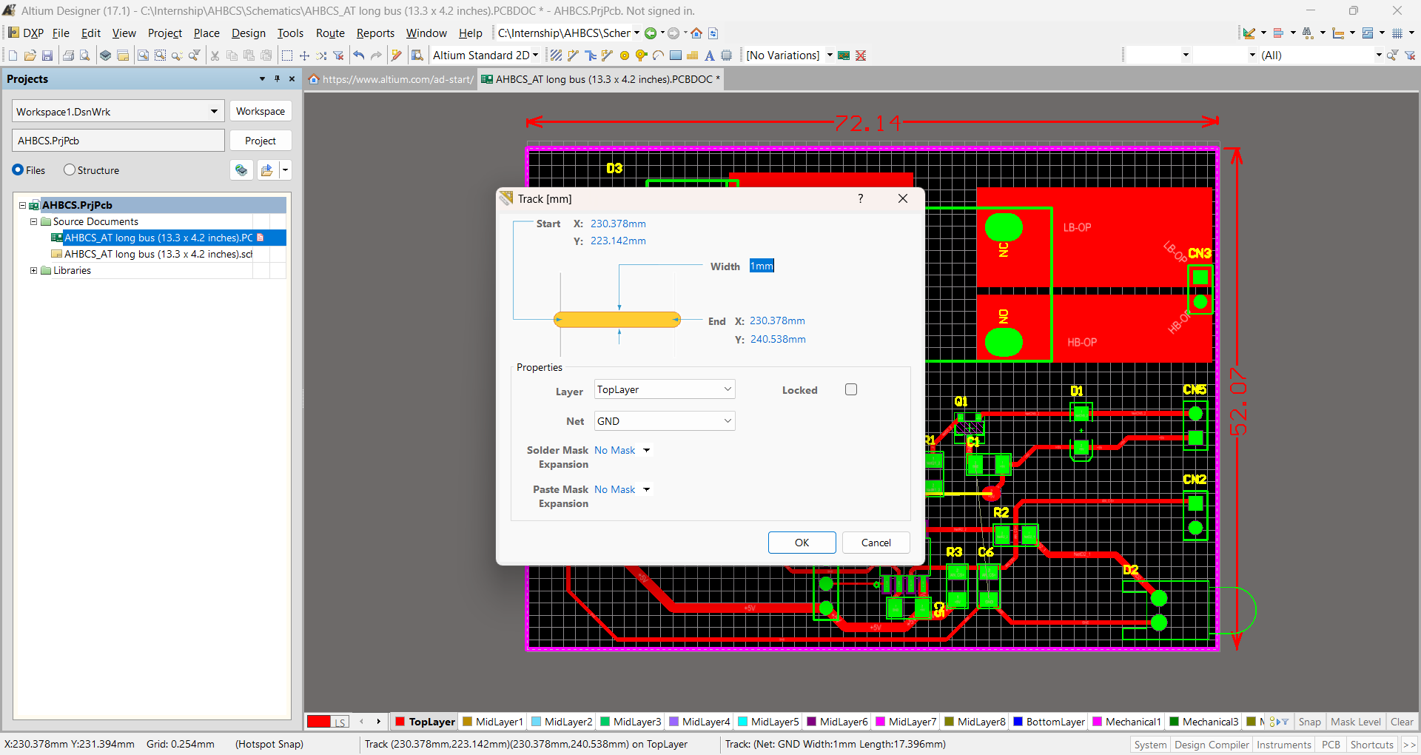
Setting the Design rules for tracks on PCB.
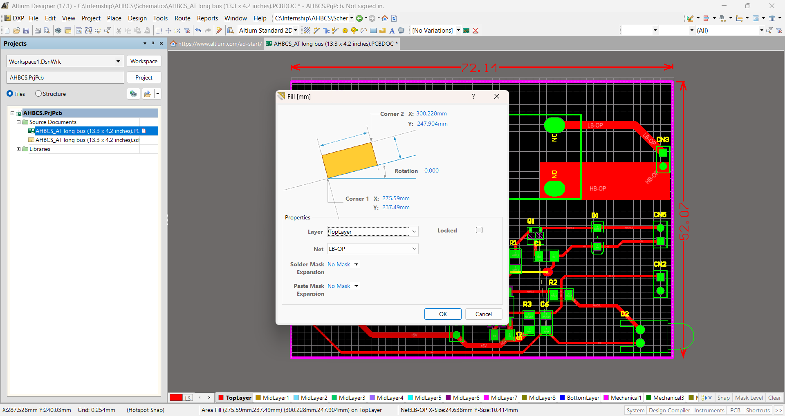
Setting the design rules for PCB.
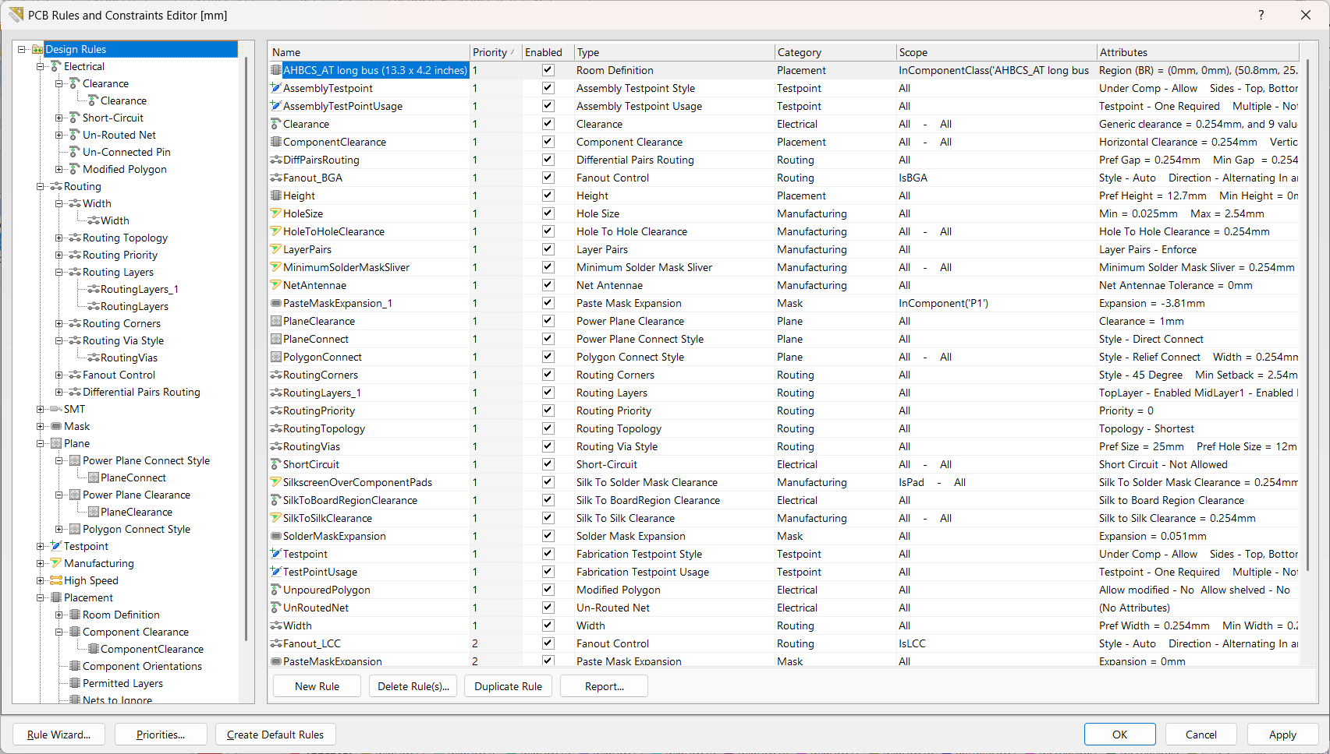

5.1.5 PCB Fabrication Process:
- Print the Layout on paper.
- Press it to the Row PCB Board.
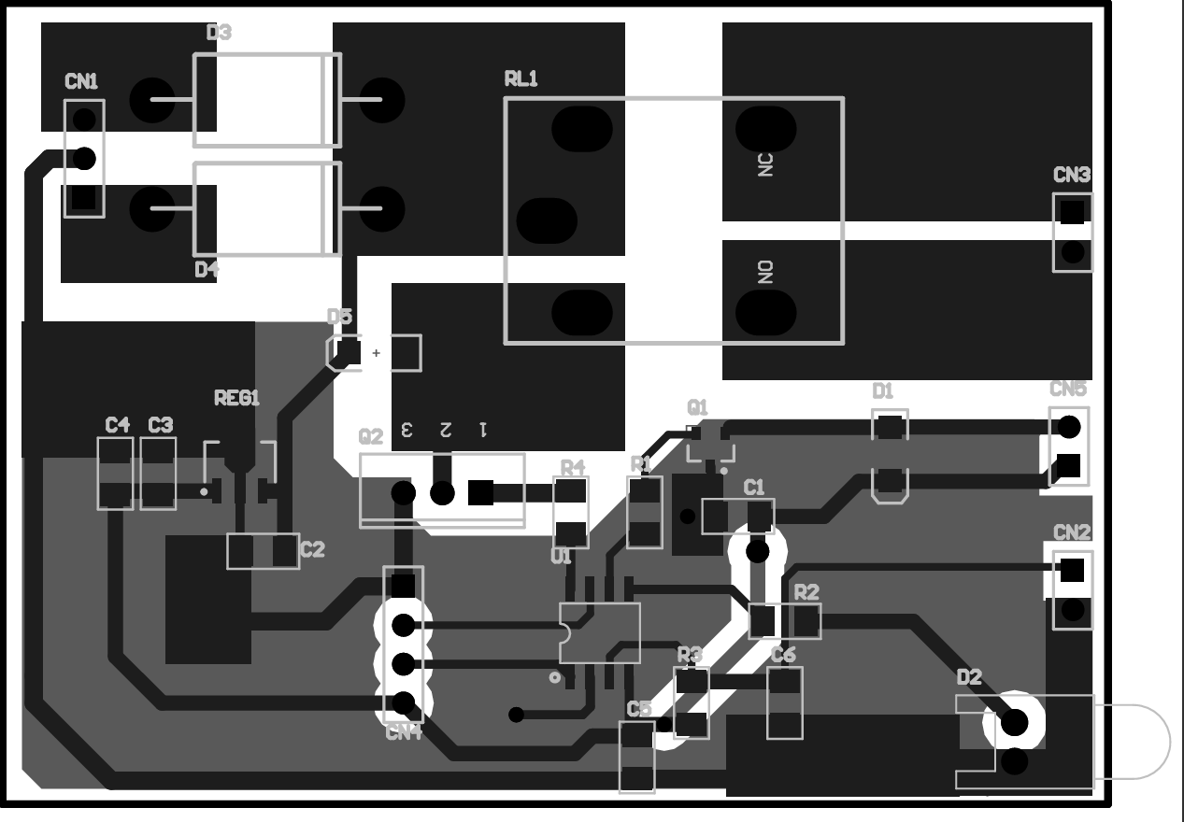

- Wash it in Ferric Chloride (Anhydrous)(Q23585) to remove extra copper on PCB laminate.

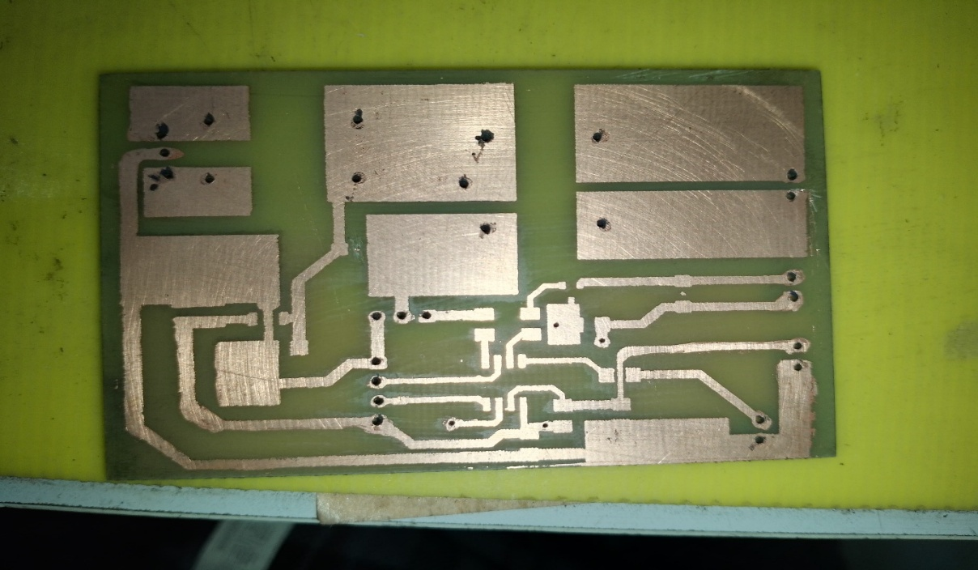

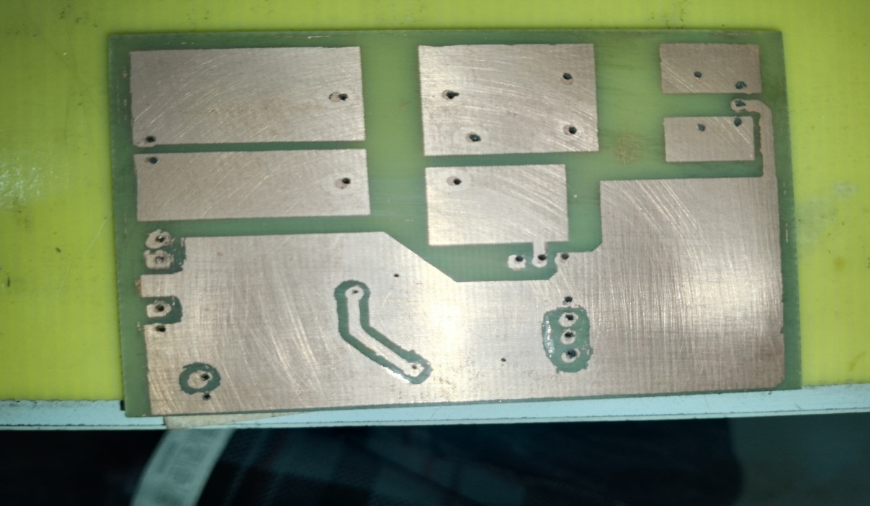
5.1.6 Soldering of PCB Components: Assembled components manually and performed through-hole and SMD soldering.
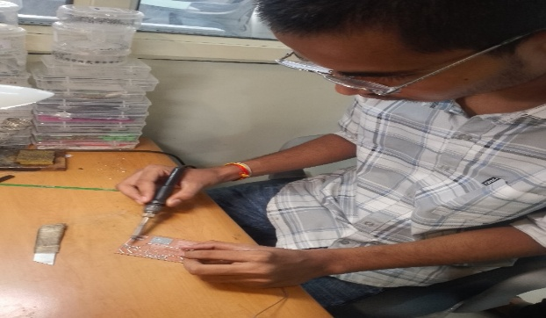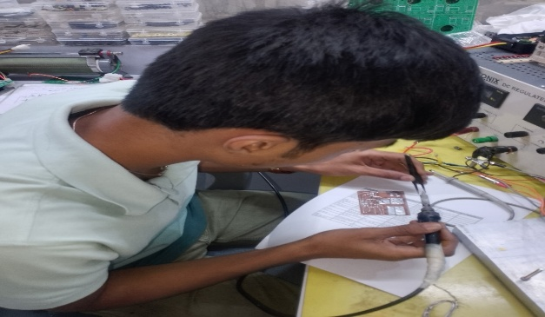
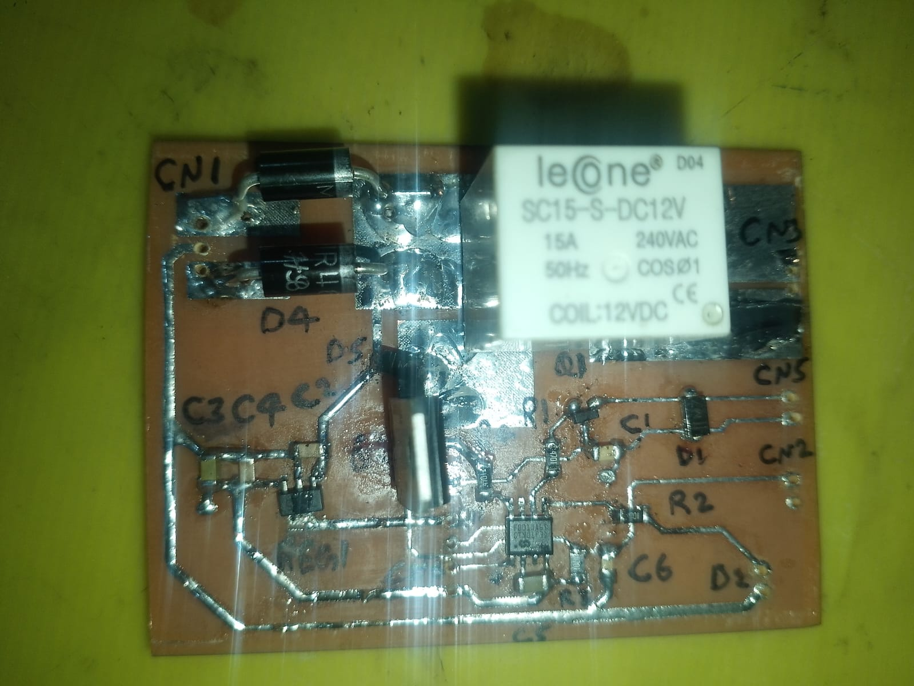

5.1.7 Continuity Testing and Debugging:
Verified connections using a multi-meter and rectified cold solder joints.
5.1.8 Generation of Bill of Materials (BOM):
Created a detailed BOM listing all electronic components and specifications.
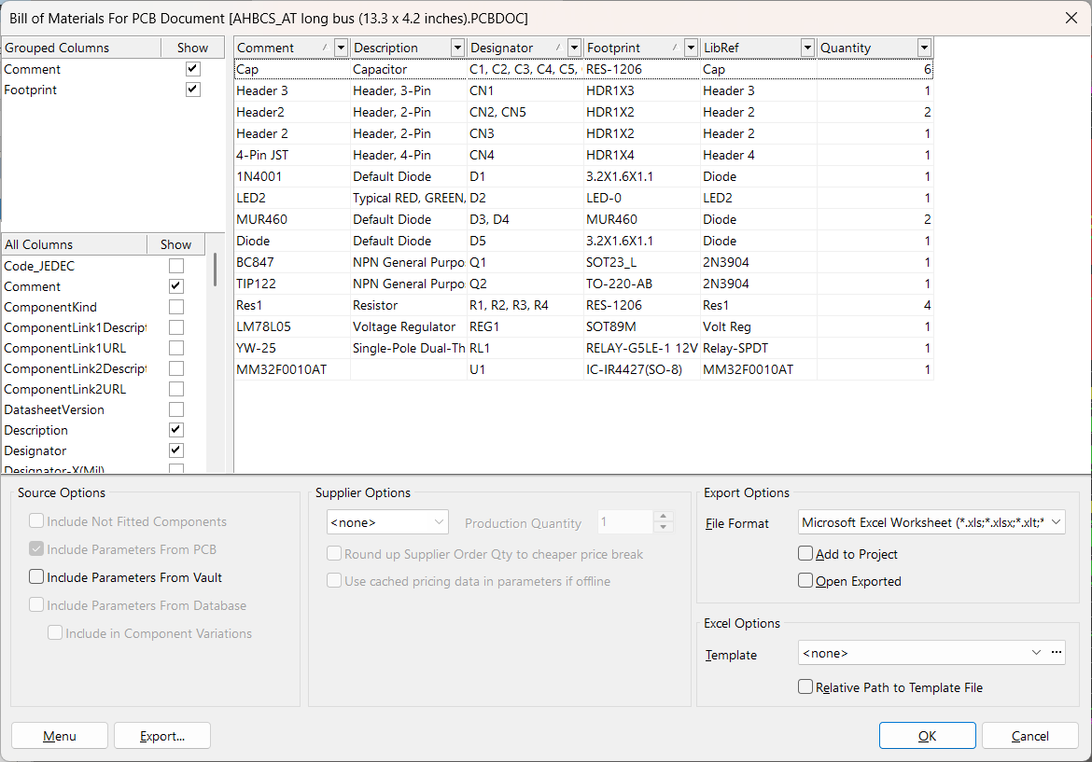

5.2 Software Design

5.2.1 Software Listing of Requirements:
- CMSIS Package: require for system startup files, vector tables, core register descriptions and debug support, system functions like NVIC (interrupts), SysTick, etc.
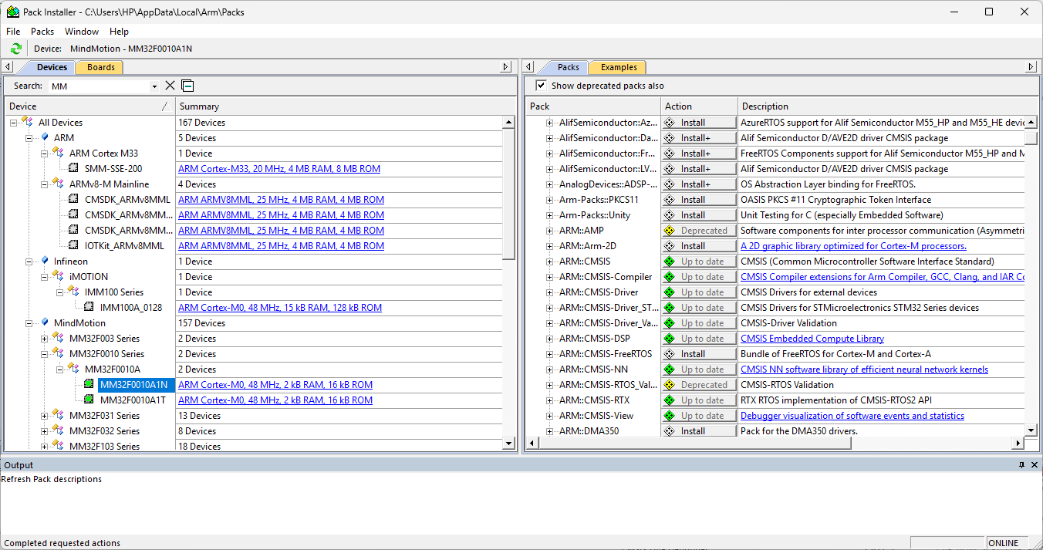

- MM32F0010 Device Support Package: This includes header files, linker scripts, startup code, peripheral drivers, and definitions specific to MM32F0010 microcontroller by MindMotion.
- system_mm32f0010.c file: This file sets up core hardware-level configurations needed before application code starts running. It works closely with the start-up file
- (startup_mm32f0010_keil.s) and defines important system initialization steps.
- startup_mm32f0010_keil.s file:
- Set up the vector table (interrupt vector table).
- Initialize the stack pointer.
- Provide default handlers for interrupts and exceptions.
- Call the system initialization function (like SystemInit()).
- Jump to the C runtime [main() function] after initializing the microcontroller's hardware.

- HAL library: MM32 HAL Library is a set of C libraries provided by Mind Motion based on the CMSIS standard and offers support for:
GPIO (General Purpose I/O)
ADC, UART, SPI, I2C, TIM (Timers)
NVIC (Interrupt controller)
RCC (Clock configuration)
Flash and power control
- Hardware and System files:
included device driver files like led.c, adcx.c, delay.c, etc and modified according to our peripheral requirements.
- Declaring Ports:
In led.c initialise ports and pins for hardware
LED1_Port GPIOA, LED_Pin GPOI_Pin_4
HBM_Port GPIOA, HMB_Pin GPIO_Pin_2
BZZ_Port GPIOA, BZZ_Pin GPIO_Pin_7
In adcx.c set Port as GPIOB and Pin as GPIO_Pin_1 to ADCxAssignPin example function and set ADC configuration for ADC1 channel 0.

5.2.2 Software Flow Chart:
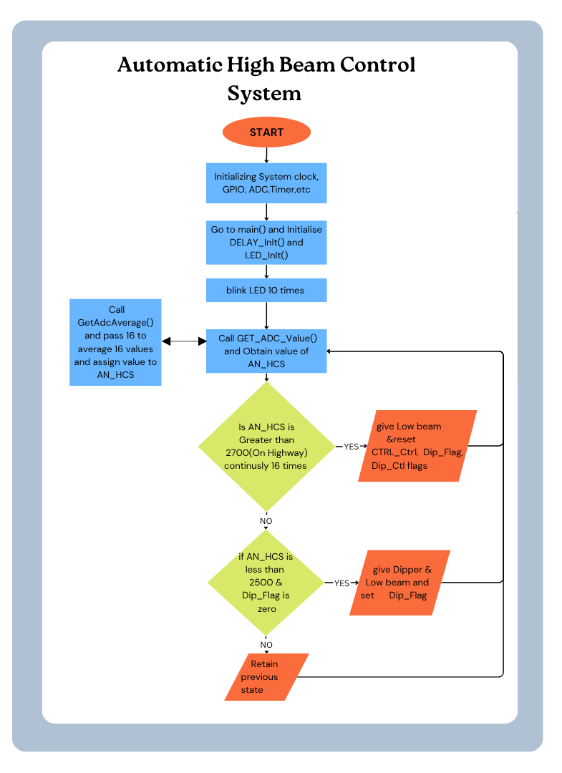
5.2.3 Description of Device Drivers Used - GPIO, ADC, M32-Link and timer drivers for MM32F0010 microcontroller.
5.2.4 Embedded Software Development on Keil Wrote and compiled code in Keil uVision using C.

6. Code Testing and Debugging:
Debugged using break-points in keil uVisoin and compile, upload and run the code. Then test and check for mistakes and debug.

7. Code Uploading and Microcontroller Programming:
Uploaded final hex file to MM32F0010 via SWD interface(MM32-Link Programmer)
Pins Details Used: +5V, Gnd, CLK, SWDIO.
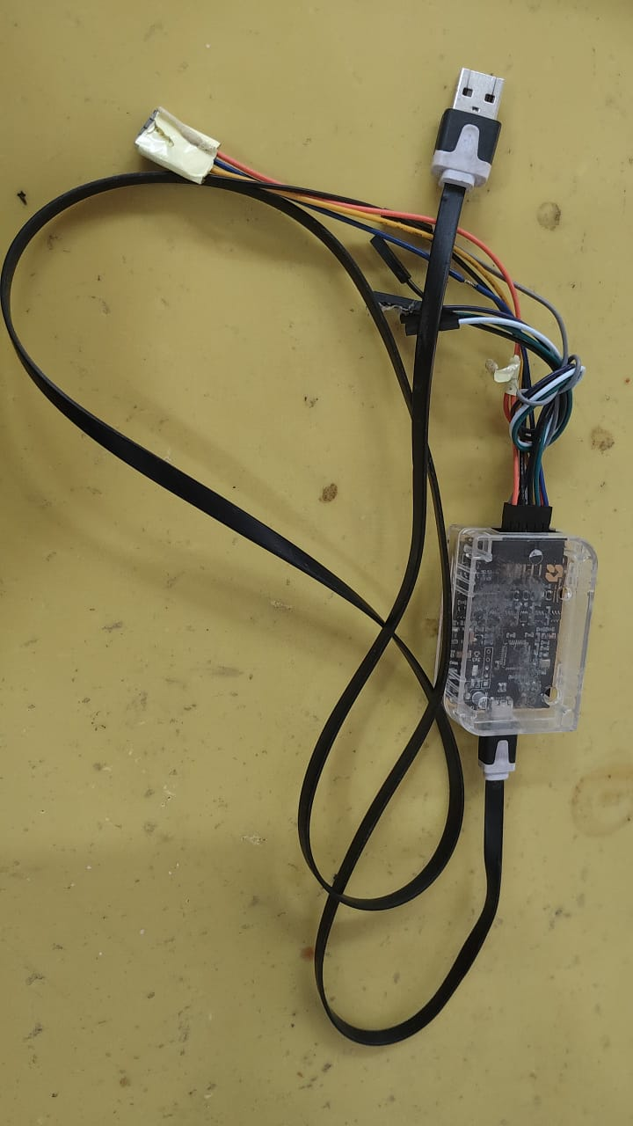

Final assembled Product:
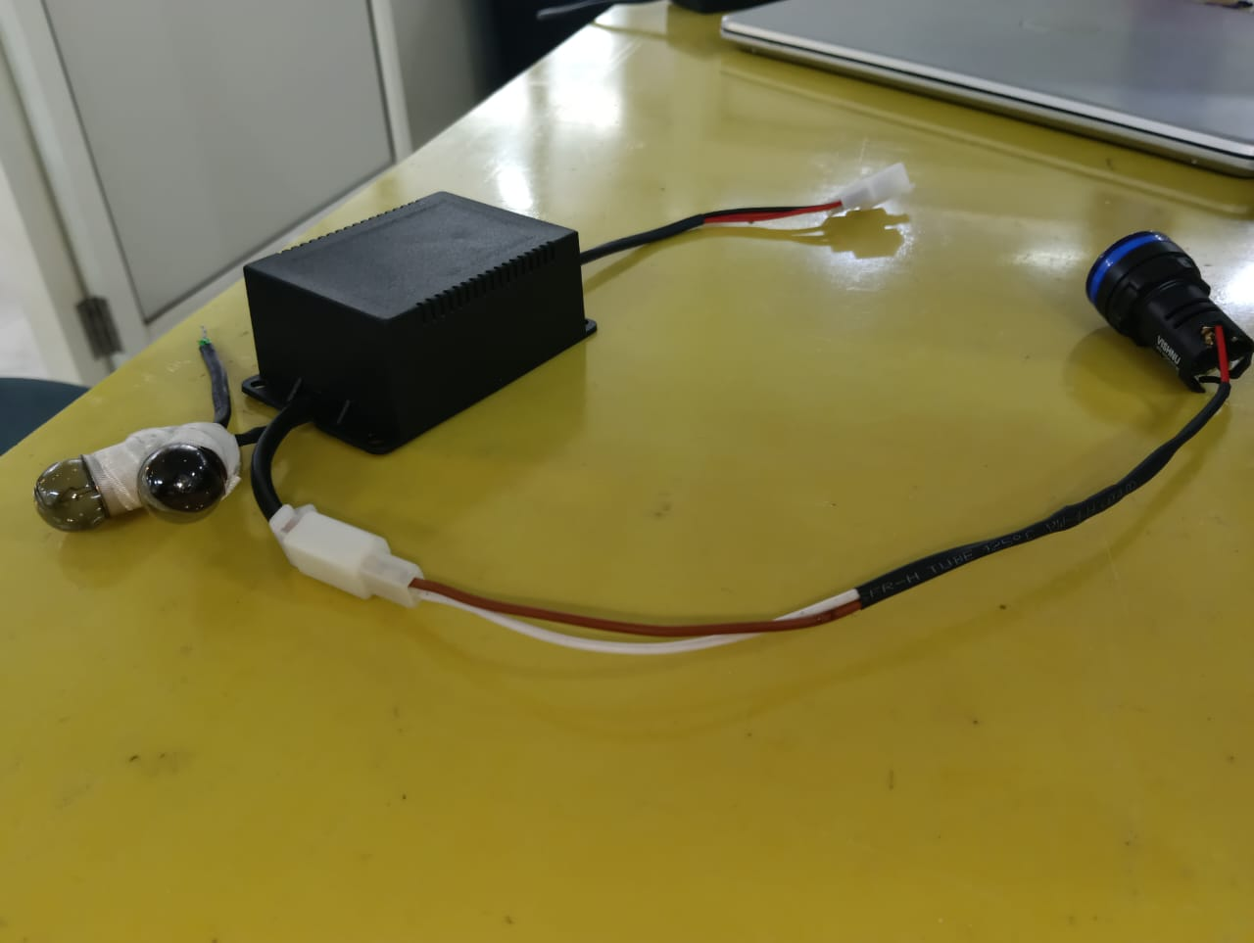

8. Challenges Faced and Solutions
Challenge 1: Routing on a Single side PCB.
Solution: Using a double-sided PCB.
Challenge 2: Finding the exact footprints for PCB Components.
Solution: Used the Footprint design Wizard on Altium for designing our own footprint according to the dimensions of our PCB element.
Challenge 3: Incorrect / Dry soldering of PCB components.
Solution: Carefully tracing the schematics with continuity tester and final placement output sheet.
Challenge 4: Improper and broken print on the PCB.
Solution: Used marker to fill the broken prints on the PCB so that the copper does not get etched away where it should not be, done before etching process.
Challenge 5: Loosely soldered PCB elements.
Solution: Proper tinning of the pins of the PCB elements before finally soldering them on the circuit.
Challenge 6: Not getting desired voltages at certain points on the PCB tracks.
Solution: Performing proper continuity tests with multimeter and debugging the PCB. Removing the excess solder from certain areas for preventing short circuit.
Challenge 7: Not being able to set proper target values for MM32F0010 Microcontroller on Keil uVision 5.42a software.
Solution: Proper Installation of all the drivers and packages from the Package Installer and making sure all the files are updated.
Challenge 8: Communication failure with Microcontroller via programmer.
Solution: Proper installation and setup of the M-32 Link driver for MM32F0010.
Challenge 9: Wrongly placed the transistor Tip122 in the pcb.
Solution: Properly make the connection of the Tip122 and make the re-correcting the problem by again soldering the component.
Challenge 10: Testing the system across different ambient conditions (dusk, night, city lighting) produced inconsistent results.

9. Outcome and Results

AHBCS prototype successfully met its core objectives:
- Automatic headlight beam switching based on real-time ambient light.
- Seamless relay operation between high and low beam with no noticeable delay.
- Accurate sensor readings with reduced false triggers.
- Microcontroller-based decision-making demonstrated consistent logic execution as per the condition table.
- All hardware components, including sensors, relays, LED indicators, and buzzers, were integrated and functional.

Performance:
- Response Time: < 500ms
- Power Consumption: Approx. 1.2W in operation
- Voltage Stability: Maintained 5V ±0.1V across components

10. Learnings and Skills Acquired

10.1 Technical Skills:
- Learned how to design and layout PCBs using Altium Designer.
- Gained experience in embedded programming with Keil µVision IDE.
- Interfaced, Emulated and programmed the MM32F0010 microcontroller.
- Connected and tested sensors, relays, and other hardware components.
- Applied techniques like voltage division, noise filtering, and circuit protection using flyback diodes and capacitors.

10.2 Soft Skills:
- Worked effectively as a team, dividing tasks based on strengths.
- Solved technical problems with subject re-study again & again.
- Practiced proper documentation and testing methods.
- Adapted quickly to new tools and workflows with limited guidance.
This project gave us real-world exposure to how embedded systems are built, tested, and deployed beyond classroom learning.

11. Conclusion
The Automatic High Beam Control System (AHBCS) project was implemented effectively & demonstrated at site. It was observed practically that if the concept is used in actual practice, It definitely can make a huge difference & will definitely ease out the night traffic by reducing human intervention in beam switching and enhancing driver safety. The system offers a cost-effective and scalable solution suitable for integration into modern vehicle lighting systems.
This project has not only improved out team’s technical competencies in embedded systems and circuit design but also provided the critical exposure to industry practices, testing protocols, and system-level integration. We now feel a grown & more matured engineer after applying ourselves to actual & hardcore electronics job.

12. Annexure
Component | Description | Datasheet Link (Full URL)
MM32F0010 | ARM Cortex-M0 Microcontroller | https://www.mindmotion.com.cn/document/2323
TIP122 | NPN Darlington Power Transistor | https://www.st.com/resource/en/datasheet/tip122.pdf
BC847 | General Purpose NPN Transistor | https://assets.nexperia.com/documents/data-sheet/BC847_SER.pdf
LDR | Light Dependent Resistor | https://www.sparkfun.com/datasheets/Sensors/LightImaging/SEN-09088.pdf
SC15-S-DC12V Relay | SPDT 12V Electromechanical Relay | https://datasheet.lcsc.com/szlcsc/1909111211_Songle-Relay-SRD-12VDC-SL-C_C108005.pdf
LM78L05 | 5V Linear Voltage Regulator | https://www.ti.com/lit/ds/symlink/lm78l05.pdf
MUR460 | Ultrafast Recovery Diode (600V, 4A) | https://www.onsemi.com/pdf/datasheet/mur460-d.pdf
1N4007 (optional) | General Purpose Rectifier Diode | https://www.onsemi.com/pdf/datasheet/1n4007-d.pdf
Capacitors/Resistors | Passive Components (Standard Values) | https://www.murata.com/en-us/products/capacitor/ceramic/datasheet
5V Buzzer | Electromagnetic Piezo Buzzer | https://www.farnell.com/datasheets/2910642.pdf
LED (Indicator) | Standard 5mm Red LED | https://www.kingbrightusa.com/images/catalog/spec/KA-3528SURC.pdf

Category | Short Description | Link (Full URL)
Microcontroller Reference | Official documentation for MM32F0010 and tools | https://www.mindmotion.com.cn/
MCU Development Tools | IDE for embedded C programming (MM32, ARM Cortex) | https://www.keil.com/
PCB Design Software | Tool used for schematic and PCB layout design | https://www.altium.com/
Datasheet Search Engine | Platform to search for ICs and components | https://www.datasheetcatalog.com/
Electronic Simulation Tool | Circuit simulation for embedded and analog circuits | https://falstad.com/circuit/
Electronics Community Forum | Peer support and expert answers for embedded electronics | https://electronics.stackexchange.com/
Buzzer & Relay Tutorials | Working and principles of relays and buzzers | https://www.electronics-tutorials.ws/
GitHub – Embedded Examples | Real-world embedded systems codebase and libraries | https://github.com/topics/embedded-systems
Report Formatting Help | Report writing and academic formatting tutorials | https://www.overleaf.com/learn/how-to/Creating_a_project_report

Project Leader
For Wings Automobile Products Pvt Ltd
Faridabad, Haryana.

